**Food Ordering System**

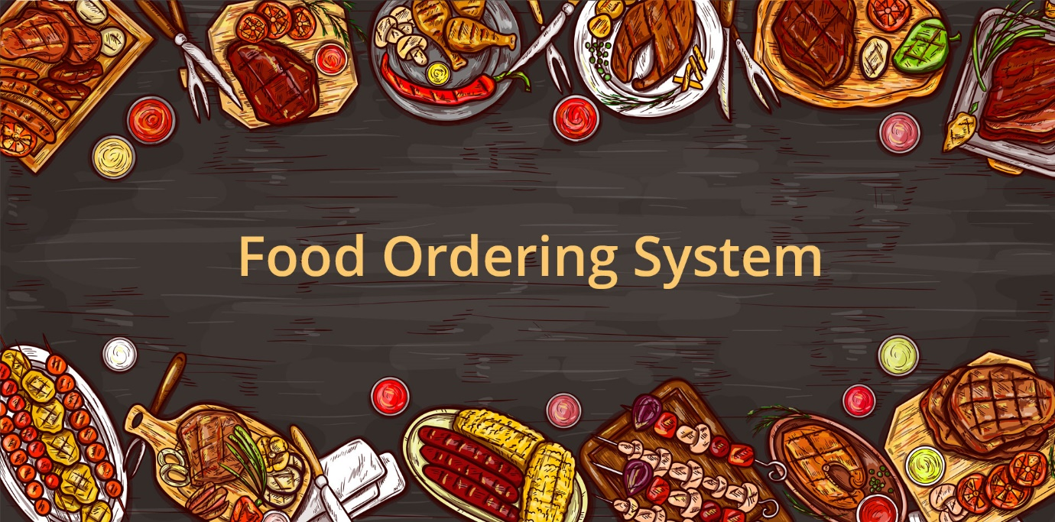

**Service at your Hands**

**Project Team Members:**

1. Alla Pranay Ketan Reddy   
2. Bandaru Omkar Karthikeya  
3. Ramakuru Lakshman  
4. Pamala Dinesh  
5.Udayagiri Sreeja

6. Pilaka Vamsi

7.Ganjikuntla Mounika

Table of Contents

1.0 Document Purpose 3

1.1 Objectives 3

2.0 Module for Project Usage Types 4

**3.0 Functionality …………………...........................4**

4.0 Technical 5

**5.0 CODE WORKING…………………………………………………………..5**

6.0 Conclusion of the Project…………………………..9

**7.0 References………………………………………………………10**

**1.0 Document Purpose**  
 **The users can order food online from anywhere through this. Developed in C++, it is fairly easy to use.**

* 1. **Objectives:**

**One of the main objectives of a restaurant to ensure customer satisfaction. Manual listing of orders by the waiters/waitresses may result to slow response in customer service. Hence, if the restaurant uses the proposed system, manipulation of orders to the customers be so easy and quick by just touching on the tablet and choosing the desired menu.**

**Existing System:**

• **For placing any orders customers have to visit hotels or restaurants to know about food items and then place order and pay. In this method time and manual work is required.**

**• While placing an order over the phone, the customer lacks the physical copy of the menu item, lack visual confirmation that the order was placed correctly.**

**• Every restaurant needs certain employees to take the order over the phone or in-person, to offer a rich dining experience and process the payment. In today’s market, labor rates are increasing day by day making it difficult to find employees when needed.**

**Proposed System:**

**An Online Food Ordering System based on the Internet of Things is presented to solve the limitations of the above system. It's a Web application-based food ordering system. A broad goal of the project is to establish a dependable, convenient, and accurate Food Ordering System. An objective will be to build a system that will undoubtedly satisfy customer service. One of the goals is to create a system that can handle a large number of orders at once and automatically calculate the bill. An essential goal is to assess its performance and acceptability in terms of security, usability, correctness, and dependability. One of the goals is to increase client-customer communication.**

**Below Pic represents the simple system architecture of the proposed system: -**

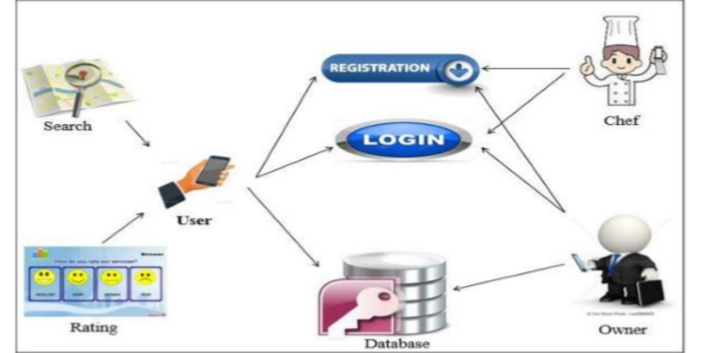

# 2.0 Module for Project Usage Types

* Menu and Search: - **The search and ordering module is the system's first and most significant module. A consumer can order meals without even creating a private profile,** **however, food cannot be ordered without access to the restaurant's menu. The details of the restaurant, such as name, location, menu, and menu-related information, will be gathered by the good meal ordering platform. A script that connects the customer to the restaurant listing is required.**

**3.0 Functionality**

**Functionality is the core of the food delivery app. When the user is ready to look for the food   
 items it results in quick order.**

**The users should have the option to effectively choose and order the food items. Most of the   
 people prefer to order online because the order placement process is quick and simple.**

**Payments play a significant role, it’s the last process of order placement if a customer faces any major or minor problem they won’t ever try again. So making the payment procedure exceedingly productive and simple to use, for this we have used only one payment method that is hard cash.**

**4.0 Technical**

**Software Requirements**

**Browser Requirements for website-**

**Suitable for any browser**

**Admin App Requirements-**

**Android Version 7.0**

**IOS Version 12.1.0**

**Hardware Requirements**

* Hard Disk – 2 GB.
* RAM required – 1 GB (minimum)
* Processor – Dual Core or Above.

**Code Compiler Requirements:**

Any compiler which can run C++ code

**5.0 CODE WORKING:**

**5.1 Menu**

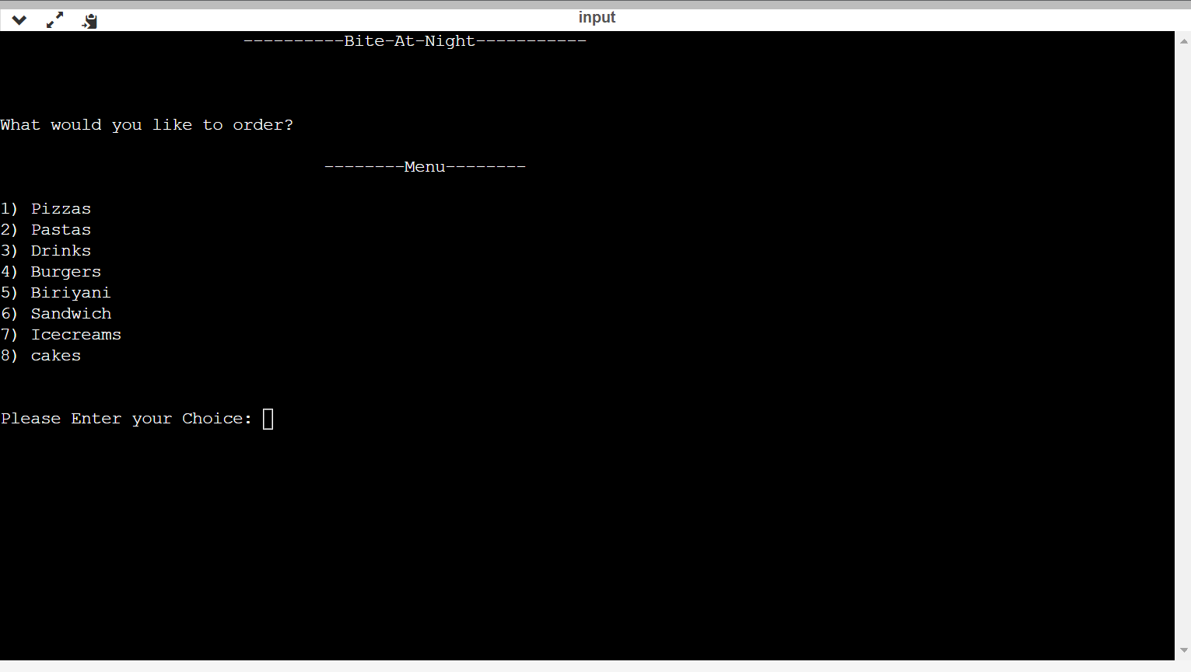

**5.2 flavors**

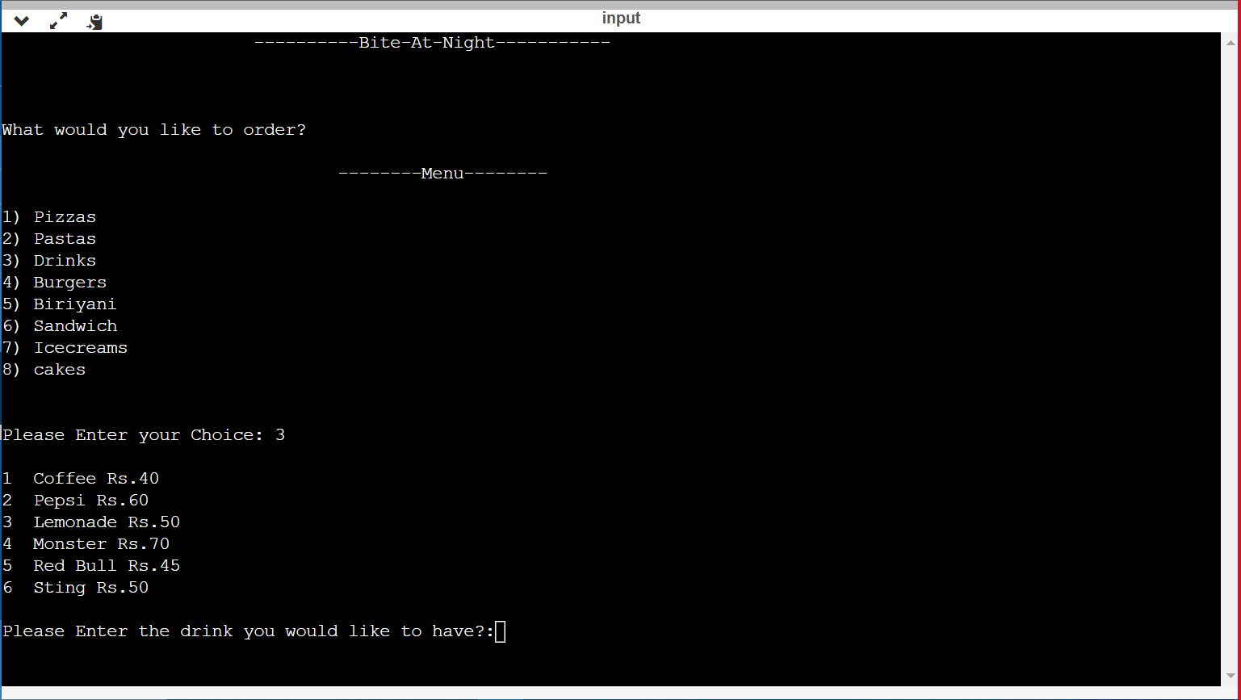

**5.3 Quantity**

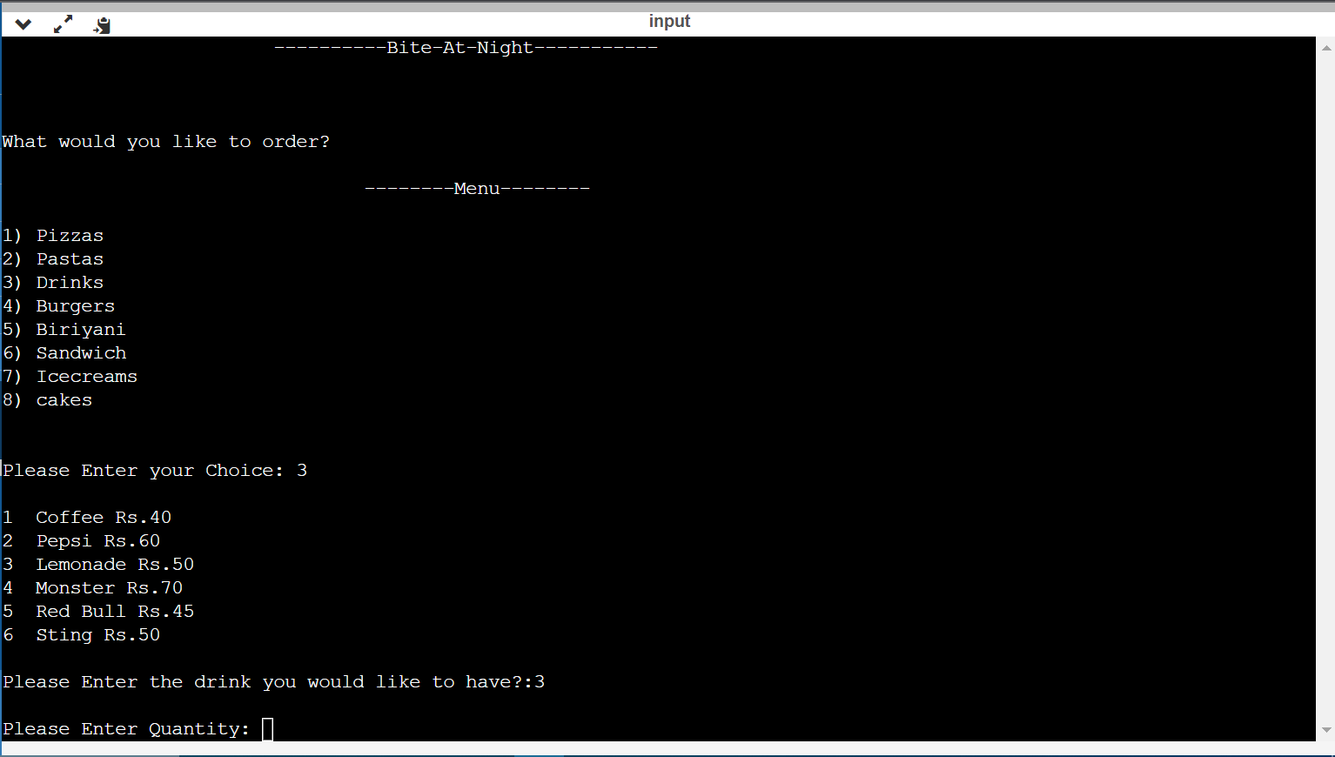

**5.4 Choosing multi-ordering**

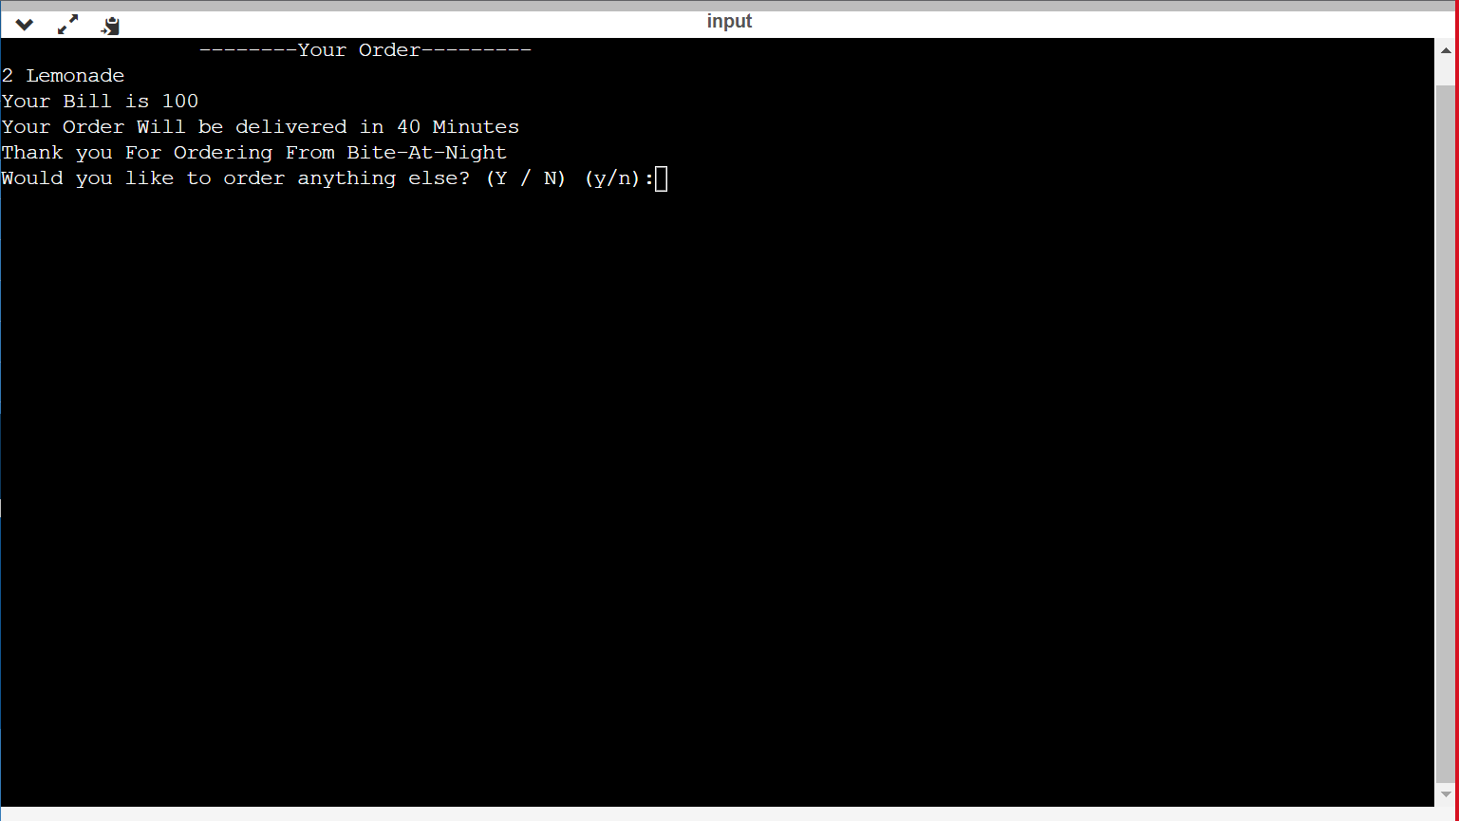

**5.5 If you want to order again it will take you to the beginning.**

**5.6 If you conclude the order it will take you to payment.**

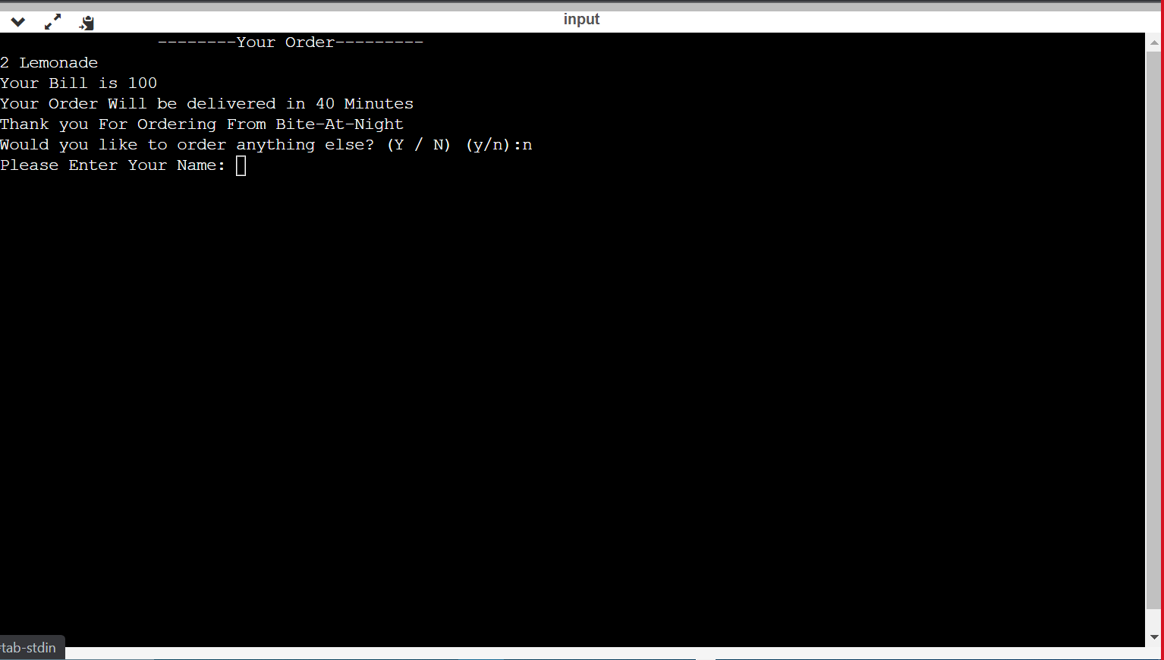

**5.7 Enter your name to proceed to final payment**

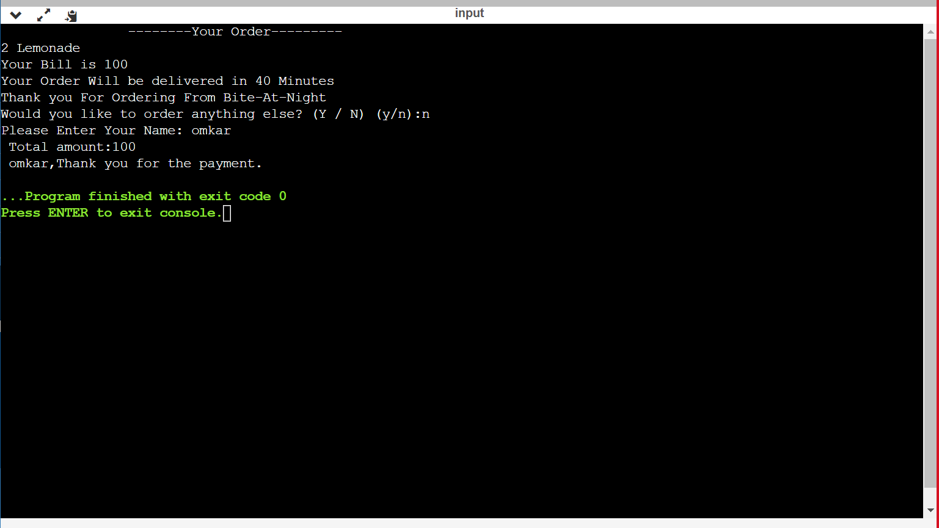

**6.0 Conclusion**

In conclusion this application eliminates the need of a waiter or decreases the waiter's duty. The advantage is that in a crowded restaurant, there is a probability that the waiters will be overburdened with orders and will be unable to service the customer's needs satisfactorily. As a result of this programme, consumers may immediately make food orders with the chef through the internet. The technology also allows the restaurant to see what's available in real-time and adjust its food availability depending on orders submitted and orders fulfilled.

**7.0 References**

**IDLE used for code testing-**

Code blocks

[**https://www.onlinegdb.com/online_c_compiler**](https://www.onlinegdb.com/online_c_compiler)

**Computer language used for coding-**

C++

**Websites used for creating free domain-**

[**https://profreehost.com/**](https://profreehost.com/)

**Tools and apps used to edit website-**

Elementor editor

[**https://wordpress.com/**](https://wordpress.com/)

**Website used to distribute the code-**

[**https://github.com/**](https://github.com/)

**Bite-At-Night website link-**

**http://biteatnight.ezyro.com/**